**Hands-on Activities with SQL**

**Objectives:**

* **Understand what the SQL is**

Understand some terms in SQL, and have a clear concept of the table structure in a relation database system.

* **Handle several basic operations using SQL to access database**

Handle the following statement:

CREATE, UPDATE, DELETE, INSERT INTO, SELETE FROM WHERE

**Resources Needed for Activities**

There is an online Try-SQL Editor at W3Schools.com:

<http://www.w3schools.com/sql/trysql.asp?filename=trysql_select_columns>

When you open this link, a Database-object is created in your browser, for testing purposes. You can try any SQL statement, and play with the Database as much as you like. The Database can be restored at any time, simply by clicking the "Restore Database" button.

WebSQL stores a Database locally, on the user's computer which means all the creation and update will be saved on your own computer. This online editor support these internet explorers: ***Chrome, Safari, and Opera***

**Activity One:**

**Create two new tables, Students and Courses.**

1. **Create table Courses:**

*CREATE TABLE Courses(*

*course_id INT NOT NULL,*

*course_name VARCHAR(45) NULL,*

*professor_name VARCHAR(45) NULL,*

*semester VARCHAR(15) NULL,*

*PRIMARY KEY (course_id));*

1. **Create table Students:**

*CREATE TABLE Students (*

*student_id INT NOT NULL,*

*firstname VARCHAR(45) NULL,*

*lastname VARCHAR(45) NULL,*

*course_id INT NULL,*

*PRIMARY KEY (student_id),*

*CONSTRAINT course_id*

*FOREIGN KEY (course_id) REFERENCES courses (course_id)*

*ON DELETE SET NULL*

*ON UPDATE CASCADE);*

There are several critical points:

* Every student should have an id, so the attribute *student_id* cannot be null.
* Attribute *student_id* is used to uniquely identify a student, so it should be set as the primary key.
* The attribute *course_id* references one attribute with the same name of table Course. We should set this attribute as a foreign key.

**Activity Two:**

**Insert some data into the created tables:**

1. *Insert data into table Courses (run one statement one time)*

*insert into courses values (14001, 'database', 'P.Kifer', '14spring');*

*insert into courses values (14002, 'network', 'P.Lee', '14spring');*

*insert into courses values (14003, 'programming', 'P.Udit', '14spring');*

*insert into courses values (14004, 'algorithm', 'P.Lemma', '14spring');*

*insert into courses values (14005, 'operating system', 'P.Thomas', '14summer');*

*insert into courses values (14006, 'system security', 'P.Johnson', '14fall');*

1. Insert data into table Students.

*INSERT INTO students VALUES (1, 'Tom', 'Parker', 14001);*

*INSERT INTO students VALUES (2, 'Abe', 'Smith', 14001);*

*INSERT INTO students VALUES (3, 'Cathy', 'Brown', 14002);*

*INSERT INTO students VALUES (4, 'Tim', 'Duncan', 14003);*

*INSERT INTO students VALUES (5, 'Rob', 'Starker', 14004);*

*INSERT INTO students VALUES (6, 'Luis', 'Wood', 14005);*

*INSERT INTO students VALUES (7, 'Smith', 'Brown', 14006);*

**Activity Three:**

**Show every table’s data, then show all the students’ name and their chosen courses’ name.**

1. **Show table Students.**

SELECT * FROM Students;

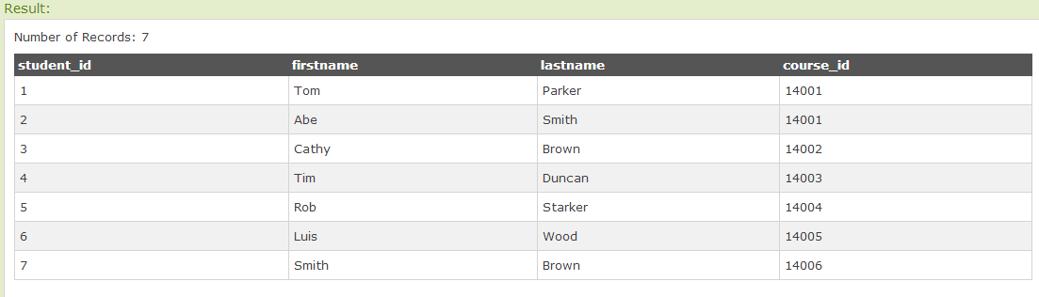

1. **Show table Courses.**

*SELECT * FROM Courses*;

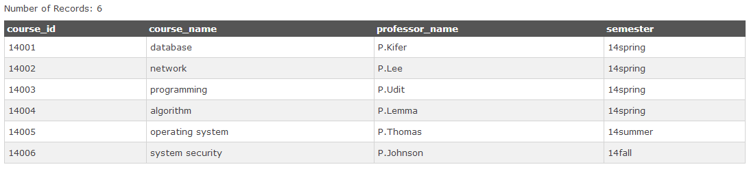

1. **Show all the students’ name and their chosen courses’ name.**

*SELECT Students.firstname, Courses.course_name*

*FROM Students, Courses*

*WHERE Students.course_id = Courses.course_id;*

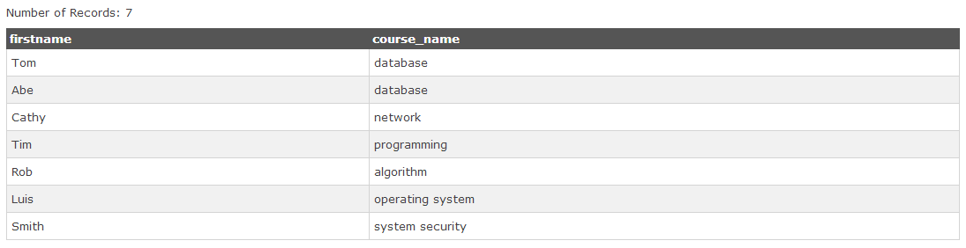

**Activity Four**

**Use UPDATE to change the professor teaching database course into P. Gao.**

*UPDATE Courses*

*SET professor_name = 'P. Gao'*

*WHERE course_name = 'database';*

Check the result:

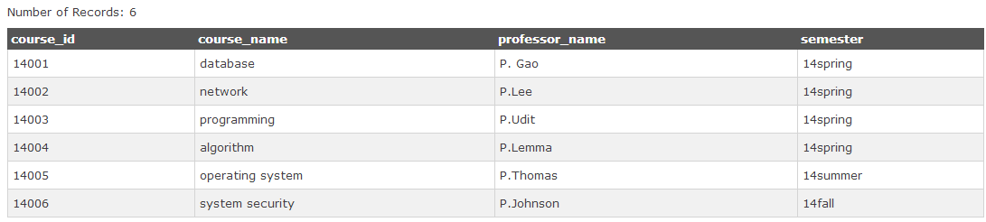SELECT * FROM Courses;

**Activity Five**

**Use DELETE statement to delete any information about the student whose id is 5.**

*DELETE FROM Students*

*WHERE student_id = 5;*

Check the result:

*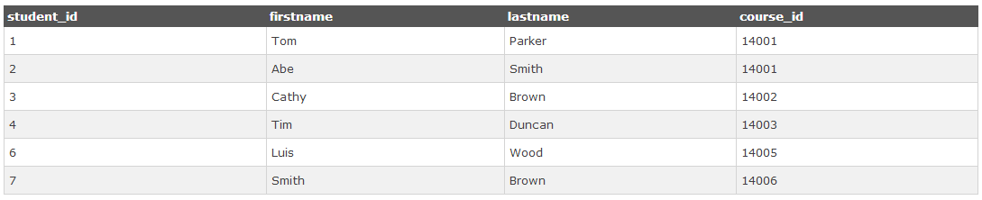SELECT * FROM Students;*

**Discussion:**

1. How many bits are used in ASCII code?
2. Please write out the binary expression of ‘A&a’.

A: &: a:

1. There are several different modes of database system: relational database, hierarchical database and network database. Which one is SQL based on?
2. Could two same rows appear in the same table in MySQL? YES/NO
3. What is a primary key? Is it necessary? What is a foreign key?
4. What is SQL’s full name? S_____ Q_____ L_____
5. Which operation on database can be realized with SQL(multiple choice):
6. Creating a table
7. Deleting a table
8. Retrieving data
9. Updating a table
10. SELECT is used to identify ________

FROM is used to identify _________

WHERE is used to identify ________

A. Columns B. Rows C. Tables